A Project Report on

**Online Shoes Shopping**

Undertaken At

**CBS Software Solution**

Submitted in fulfillment for the awards of degree in

**Master of Computer Application**

[Batch 2023-2025]

**SUBMITTED BY**

Harsoda Hetasvi

Kaila Mansi

**UNDER THE GUIDANCE OF**

Dr. Falguni Parsana[Internal Guide]

**Department Head**

Dr. Hitendra Donga

**MCA Program Coordinator**

Mr. Divyesh Gohel

**SUBMITTED TO**

ATMIYA UNIVERSITY - RAJKOT



**Declaration of Authenticity and Originality**

I, Harsoda Hetasvi, hereby declare that the project entitled "Walkway Shoes" is an original work carried out by me as a part of my academic pursuit. This project is the result of my independent research, development, and creative effort. It has been prepared with utmost sincerity and dedication. All the information, features, and functionalities included in this project—such as product catalog browsing, advanced search and filtering options, secure payment integration, and user-friendly interface—have been designed and implemented based on my own analysis, coding, and innovation.

The purpose of " Walkway Shoes " is to provide a comprehensive platform for users to explore and purchase various types of shoes from the comfort of their homes. It reflects the growing importance of e-commerce and highlights how online platforms can enhance the shopping experience by offering convenience, variety, and exclusive deals.

I confirm that this work has not been submitted previously, in part or full, for any academic evaluation, publication, or any other purpose. It stands as an independent and original contribution to the field of e-commerce application development.

I also take full responsibility for the authenticity and originality of this project. I understand that any false claim can result in disciplinary action as per institutional policies.

Harsoda Hetasvi [230823029]

Date: / /

# **ACKNOWLEDGEMENT**

We feel great pleasure in submitting this project report as a part of our M.C.A Semester 4 curriculum. A practical study plays an important role.

For the successful completion of our project, we would especially like to thank our parents for their support and unconditional help. We would also like to thank our Project Guides Mrs. Falguni Parsanafor their constant support and help in implementation of this project.

My sincere thanks also go to the online tech communities and individuals who share their knowledge and help learners like me to overcome challenges and expand their skills.

Lastly, we would also like to thank the faculties and staff members of Atmiya University M.C.A. College, Rajkot.

Harsoda Hetasvi [230823029]

Date: / /

# **ABSTRACT**

Online Shoes shopping is a web application of electronic commerce which allows consumers to directly buy products from a Sellers over the internet using this system. It provides the user with a catalog of different types of products available for purchase in the store.

Going from one shop to another can be exhausting and time-consuming. Sometimes, you spend hours roaming around looking for a Shoes, but you don't find anything. Discounts and offers are given only for a short period. Sometimes malls and markets are so crowded that you can barely do shopping.

Our web application to, you have access to a wide range of Shoes products. From Shoes and Shoes accessories everything is just a click aware to buy that product. You can shop at any time of the day. The online shopping store is at your service 24/7. You get exclusive deals on online products, which are not available at stores.

**COMPANY PROFILE**

|  |  |
| --- | --- |
| **Company Name** | CBS Software Solution |
| **Technologies** | PHP, WordPress, ASP.Net, C#, SEO, Digital Marketing |
| **Address** | 119, Nakshatra – V, Opp. Raj Palace, Sadhu Vaswani Road, University Road, Rajkot – 360 005 (Gujarat, India) |
| **Website** | **www.cbssoftware.in** |
| **Email** | [**info@cbssoftsol.com**](mailto: info@cbssoftsol.com) |
| **Contact Number** | Mrs. Bhumita Radadiya  +91 9428299382 |

**PROJECT PROFILE**

|  |  |
| --- | --- |
| STUDENT INFORMATION | |
| Name  Hetasvi Harsoda  Mansi Kaila | **Enrollment Numbers**  230823029  230823041 |
| PROJECT DETAILS | |
| Project Title | The Shoes Box |
| Duration | 4 Months |
| Name of Project | Walkway Shoes |
| Platform | PHP  MySQL |
| Team Size | 2 |
| GUIDE INFORMATION | |
| Names of Guides | Dr. Falguni Parsana |

**Index**

|  |  |  |
| --- | --- | --- |
| Chapter | Title | Page No. |
| 1 | **Overview of the accepted SDLC Model** | **1** |
| 2 | **Requirement Gathering and Analysis** | **2** |
|  | 2.1 Type of Project | **2** |
| 2.2 Method of collecting requirements | **2** |
| 3 | **About the Tools** | **3** |
|  | 3.1 HTML | **3** |
| 3.2 CSS | **3** |
| 3.3 Bootstrap | **4** |
| 3.4 JavaScript | **4** |
| 3.5 AJAX | **5** |
| 3.6 MySQL | **5** |
| 3.7 XAMPP Server | **5** |
| 3.8 PHP | **6** |
| 3.9 Brackets | **6** |
| 4 | **System Requirement Specification** | **7** |
|  | 4.1 Introduction | **7** |
| 4.2 System Modules | **8** |
| 4.3 External Interface Requirements | **9** |
| 4.4 Non-functional Requirements | **10** |
| 4.5 Feasibility Study | **11** |
| 5 | **System Design** | **12** |
|  | 5.1 Data Dictionary | 11 |
| 5.2 Use-case Diagram | 17 |
| 5.3 Activity Diagram | 19 |
| 5.4 Class Diagram | 20 |
| 5.5 Sequence Diagram | 21 |
| 5.6 Gantt Chart | 22 |
| 6 | **Screenshots** | **23** |
| 7 | **Agile Documentation** | **34** |
| 8 | **Future Enhancements** | **37** |
| 9 | **TimeLine** | **39** |
| 10 | **References and Bibliography** | **41** |

**CHAPTER 1**

**OVERVIEW OF THE ACCCEPTED SDLC MODEL**



**Iterative Model**

* An iterative life cycle model does not start with a full specification of requirements.
* In this model, the development begins by specifying and implementing just part of the software, which is then reviewed in order to identify further requirements.

**CHAPTER 2**

**REQUIREMENT GATHERING AND ANALYSIS**

**2.1 Type of project**

The proposed system will be a **web-based application**, designed to run in a browser environment and be accessible through any device with an active **internet connection**. The system will support multiple users and allow access to authorized personnel from any location, enhancing flexibility and scalability.

The application will be hosted on a **web server**, and the users will interact with it via standard web browsers such as Google Chrome, Mozilla Firefox, Microsoft Edge, etc. The system's frontend will be user-friendly, while the backend will be managed securely to store, retrieve, and manipulate data as per user interaction.

**2.2 Method of collecting requirements**

The primary method of collecting the requirements for the system will be through **interview sessions with the system owner**. Interviews are one of the most effective requirement gathering techniques, as they allow direct interaction with stakeholders and enable in-depth understanding of the needs, goals, and pain points.

During the interviews, the system analyst will ask both **open-ended and close-ended questions** to gain clarity on the functional and non-functional requirements of the system. Key topics will include business processes, user roles, data input/output, system workflows, and security expectations.

**CHAPTER 3**

**ABOUT THE TOOLS**

**3.1 HTML (Hypertext Mark-up Language)**

HTML is the backbone of any website. It is a mark-up language used to create the basic structure and content of web pages. HTML uses elements like headings, paragraphs, tables, images, links, forms, and more to build the layout of a website. In this project, HTML was used to design the structure of each webpage, defining where content such as text, buttons, and forms should appear.

* Foundation of all web pages.
* Structures content using elements like headings, paragraphs, images, lists, forms, and tables.
* Used to design pages like homepage, product listing, login/registration, cart, and checkout.
* Key elements used: <div>, <form>, <table>, <img>.
* Helped organize and display content clearly.

**3.2 CSS (Cascading Style Sheets)**

CSS is used to control the visual appearance of web pages written in HTML. It allows developers to apply styles such as colours, fonts, spacing, positioning, borders, and animations. CSS makes websites visually attractive and helps in creating layouts that are user-friendly and responsive. In this project, CSS was used to enhance the design and make the interface more appealing and consistent across different screen sizes.

* Controls the visual appearance of the website.
* Applied styles like colors, fonts, margins, paddings, and animations.
* Used to create clean, user-friendly interfaces.

**3.3 Bootstrap**

Bootstrap is a popular front-end framework that simplifies web design by providing pre-designed components like navigation bars, modals, buttons, and a responsive grid system. It uses HTML, CSS, and JavaScript to build mobile-first, responsive websites quickly. In this project, Bootstrap was used to create a consistent and responsive layout without writing custom CSS for every element. It significantly reduced development time while ensuring professional-looking UI components.

* Responsive front-end framework.
* Includes ready-made components (buttons, modals, navbars, grids).
* Simplifies building mobile-friendly, professional websites.

**3.4 JavaScript**

JavaScript is a high-level programming language that allows web pages to become interactive and dynamic. It can manipulate HTML and CSS on the fly, validate forms, create animations, handle user inputs, and much more. JavaScript runs on the client side (in the browser), enabling instant responses to user actions without needing to reload the page. In this project, JavaScript was used for interactive features like form validation, dynamic content updates, menu interactions, and more.

* Updated cart totals in real-time.
* Enabled dynamic content loading.
* Allowed instant responses to user actions without page reload.

**3.5 AJAX (Asynchronous JavaScript and XML)**

AJAX is a technique that allows web applications to communicate with the server asynchronously, meaning it can send and retrieve data from the server in the background without refreshing the entire page. This enhances the user experience by making the web application faster and more responsive. In this project, AJAX was used to perform operations like loading data, submitting forms, and updating content dynamically without reloading the page.

* Avoids full page reloads during interactions.
* Improved speed and responsiveness of the site.

**3.6 MySQL**

MySQL is an open-source relational database management system used to store and manage data. It supports operations like inserting, updating, deleting, and retrieving data efficiently using SQL (Structured Query Language). In this project, MySQL was used to store user data, product details, order information, and other dynamic content required by the web application. The database was connected to the PHP backend to perform CRUD (Create, Read, Update, Delete) operations.

**3.7 XAMPP Server**

XAMPP is a free and open-source cross-platform web server solution package that includes Apache (web server), MySQL (database), PHP (scripting language), and Perl. It provides a local development environment, allowing developers to build and test their applications offline before deploying them to a live server. In this project, XAMPP was used to run the application locally, manage the MySQL database, and execute PHP scripts during the development phase.

**3.8 PHP (Hypertext Pre-processor)**

PHP is a powerful server-side scripting language used to develop dynamic and interactive web applications. It can handle tasks like processing form data, managing sessions, and interacting with databases. PHP runs on the server and generates dynamic HTML content that is sent to the user's browser. In this project, PHP was used to manage server-side logic such as user authentication, form handling, database connectivity, and back-end processing.

**3.9 Brackets**

Brackets is a modern, open-source code editor specifically designed for web development. It supports a wide range of programming languages like HTML, CSS, JavaScript, and PHP. It comes with features like live preview, inline editing, syntax highlighting, and extensions for added functionality. Brackets was used as the primary development environment for writing, editing, and organizing the code for this project due to its simplicity and real-time editing capabilities.

**CHAPTER 4**

**SYSTEM REQUIREMENT SPECIFICATION**

* 1. **Introduction**
* Online Shoes shopping is a web application of electronic commerce which allows consumers to directly buy products from a Sellers over the internet using this system. It provides the user with a catalog of different types of products available for purchase in the store.

* + - **Purpose**
* The purpose of this software requirement specification document is to sell shoes.

* + - **Scope**
* This system will be use by any common public.

* + - **Operating Environment**
    - **Client-Side requirement:**
* To use the web application, a computer with an internet connection and a web browser is required.
  + - **Server-Side requirement:**
* Operating System: Windows 7 or Higher
* Memory: 4 GB or Higher
* Storage: 128 GB or Higher
* Server Software: MySQL Server

* + - **User Classes**
    - **Administrators**
      * Can Add, Update and Remove Products, Category, Brand, Rating and Other Administrators.
    - **User**
      * Users Should be able to see the Products and Purchase.

* 1. **System Modules**

* + - **Introduction**
  + Purpose of Documentation.
  + Target Audience.
  + System Overview.

* + - **Authentication**
  + User and Admins can login to the System by entering proper credentials.

* + - **Product Management**
  + Admin can Add, Update and Remove Products.
  + Product Categories.
  + User can choose Attributes (size, brand).
  + Product Rating
    - **Shopping Cart**
  + User can Add and Remove Products from Cart.
  + Update Quantity.
  + Calculate Subtotal and Total.

* + - **Checkout**
  + Shipping Information.
  + Payment Methods.
    - Case on Delivery (COD)
    - PayPal
  + Order Confirmation.

* + - **User Profiles**
  + User Dashboard.
  + Order History.

* + - **Security**
  + Data Encryption.
  + User Data Protection.

* 1. **External Interface Requirements**
     1. **Hardware Interface Requirements**
  + 512+ MB of RAM
  + Multimedia Keyboard and Mouse
  + 1.0+ GHz Processor
  + Monitor

* + 1. **Software Interface Requirements**
  + Operating System: Microsoft Windows 7 or Above
  + Front End Tools: HTML, CSS, JS and BOOTSTRAP
  + Back End Tools: PHP and MySQL

* + 1. **User Interface Requirements**
  + Stable Internet Connection.

* + 1. **Communication Requirements**
  + Local Internet
  + Internet

* 1. **Non-functional Requirements**

* + 1. **Performance Requirements**
  + Overall System should be fast and error-free.
  + It should have built-in error checking and correction facilities.
  + The system should be able to handle large amounts of data.

* + 1. **Security Requirements**
  + Users must Have Proper permission to perform tasks.
  + Administrator has more rights than the user.

* 1. **Feasibility Study**
  + A feasibility study is a preliminary investigation of a proposed system to decide whether the system can run smoothly with organization.

* + 1. **Operational Feasibility**
  + Operational feasibility is the measure of how well a proposed system solves the problems, and take advantage of the opportunities identified in the requirements analysis phase of the system development.

* + 1. **Technical Feasibility**
  + Technical feasibility determines whether the work for the project can done with existing equipment, software technology and available personal.
    - Operating Environment
    - Windows: 7/8/10/11
    - Minimum RAM: 1GB
    - Storage: 10GB
    1. **Economic Feasibility**
  + Economic feasibility determines whether there are sufficient benefits in creating to make the cost acceptable, or is the cost of the system too high.
  + So signifies cost benefit analysis and savings on the behalf of the cost benefit analysis.

* + 1. **Schedule Feasibility**
  + How long will it take to get the technical expertise?
  + We may have the technology, but that doesn't mean we have the skill required to properly apply that technology.

**CHAPTER 5**

**SYSTEM DESIGN**

**5.1 Data Dictionary**

* A data dictionary contains metadata i.e. data about the database. The data dictionary is very important as it contains information such as what is in the database, who is allow to access it, where the database physically stored, etc. The users of the database normally do not interact with the data dictionary; it is only handled by the database administrators.

**Database Name: theshoesbox**

1. **Table Name: - users**

|  |  |  |
| --- | --- | --- |
| Colum Name | Data Type | Constrain |
| id | Int | Primary key (AI) |
| name | Varchar(100) | Not Null |
| email | Varchar(100) | Not Null |
| phoneno | Varchar(10) | Not Null |
| password | Varchar(100) | Not Null |
| usertype | Varchar(20) | Not Null |

1. **Table Name: - category**

|  |  |  |
| --- | --- | --- |
| Colum Name | Data Type | Constrain |
| id | Int | Primary key (AI) |
| name | Varchar(50) | Not Null |

1. **Table Name: - brand**

|  |  |  |
| --- | --- | --- |
| Colum Name | Data Type | Constrain |
| id | Int | Primary key (AI) |
| name | Varchar(50) | Not Null |

1. **Table Name: - product**

|  |  |  |
| --- | --- | --- |
| Colum Name | Data Type | Constrain |
| id | Int | Primary key (AI) |
| name | Varchar (50) | Not Null |
| cat_id | Int | Foreign Key (References Table : category , Colum Name : id ) |
| brand_id | Int | Foreign Key (References Table : brand , Colum Name : id ) |
| price | Int | Not Null |
| pro_image | Varchar (59) | Not null |
| pro_details | Varchar(200) | Not null |

1. **Table Name: - cart**

|  |  |  |
| --- | --- | --- |
| Colum Name | Data Type | Constrain |
| id | Int | Primary Key (AI) |
| product_id | Int | Foreign Key (References Table : product, Colum Name : id ) |
| user_id | Int | Foreign Key (References Table : users, Colum Name : id ) |
| quantity | Int | Not Null |

1. **Table Name: - addressdetails**

|  |  |  |
| --- | --- | --- |
| Colum Name | Data Type | Constrain |
| id | Int | Primary Key (AI) |
| user_id | Int | Foreign Key (References Table : users , Colum Name : id ) |
| name | Varchar (50) | Not Null |
| address | Varchar (100) | Not Null |
| city | Varchar (50) | Not Null |
| state | Varchar (50) | Not Null |
| pincode | Int | Not Null |
| phoneno | Int | Not Null |
| email | Varchar (50) | Not Null |

1. **Table Name: - order**

|  |  |  |
| --- | --- | --- |
| Colum Name | Data type | Constrain |
| id | Int | Primary Key (AI) |
| user_id | Int | Foreign Key (References Table : users , Colum Name : id ) |
| product_id | Int | Foreign Key (References Table : product, Colum Name : id ) |
| address_id | Int | Foreign Key (References Table : addressdetails, Colum Name : id ) |
| rate | Int | Not Null |
| pro_size | Int | Not Null |
| quantity | Int | Not Null |
| totalprice | Int | Not Null |
| status | Varchar(50) | Not Null |

1. **Table Name: - contact**

|  |  |  |
| --- | --- | --- |
| Colum Name | Data Type | Constrain |
| id | Int | Primary Key (AI) |
| name | Varchar (50) | Not Null |
| email | Varchar (50) | Not Null |
| subject | Varchar (50) | Not Null |
| message | Varchar (50) | Not Null |

1. **Table Name: - Ratings**

|  |  |  |
| --- | --- | --- |
| Colum Name | Data Type | Constrain |
| id | Int | Primary Key (AI) |
| Product_id | Varchar (11) | Not Null |
| rating | Varchar (11) | Not Null |
| User_id | Varchar (11) | Not Null |

**5.2 Data Flow Diagram**

* **Context Level DFD**



**5.3 Use-case Diagram**

* **Admin**

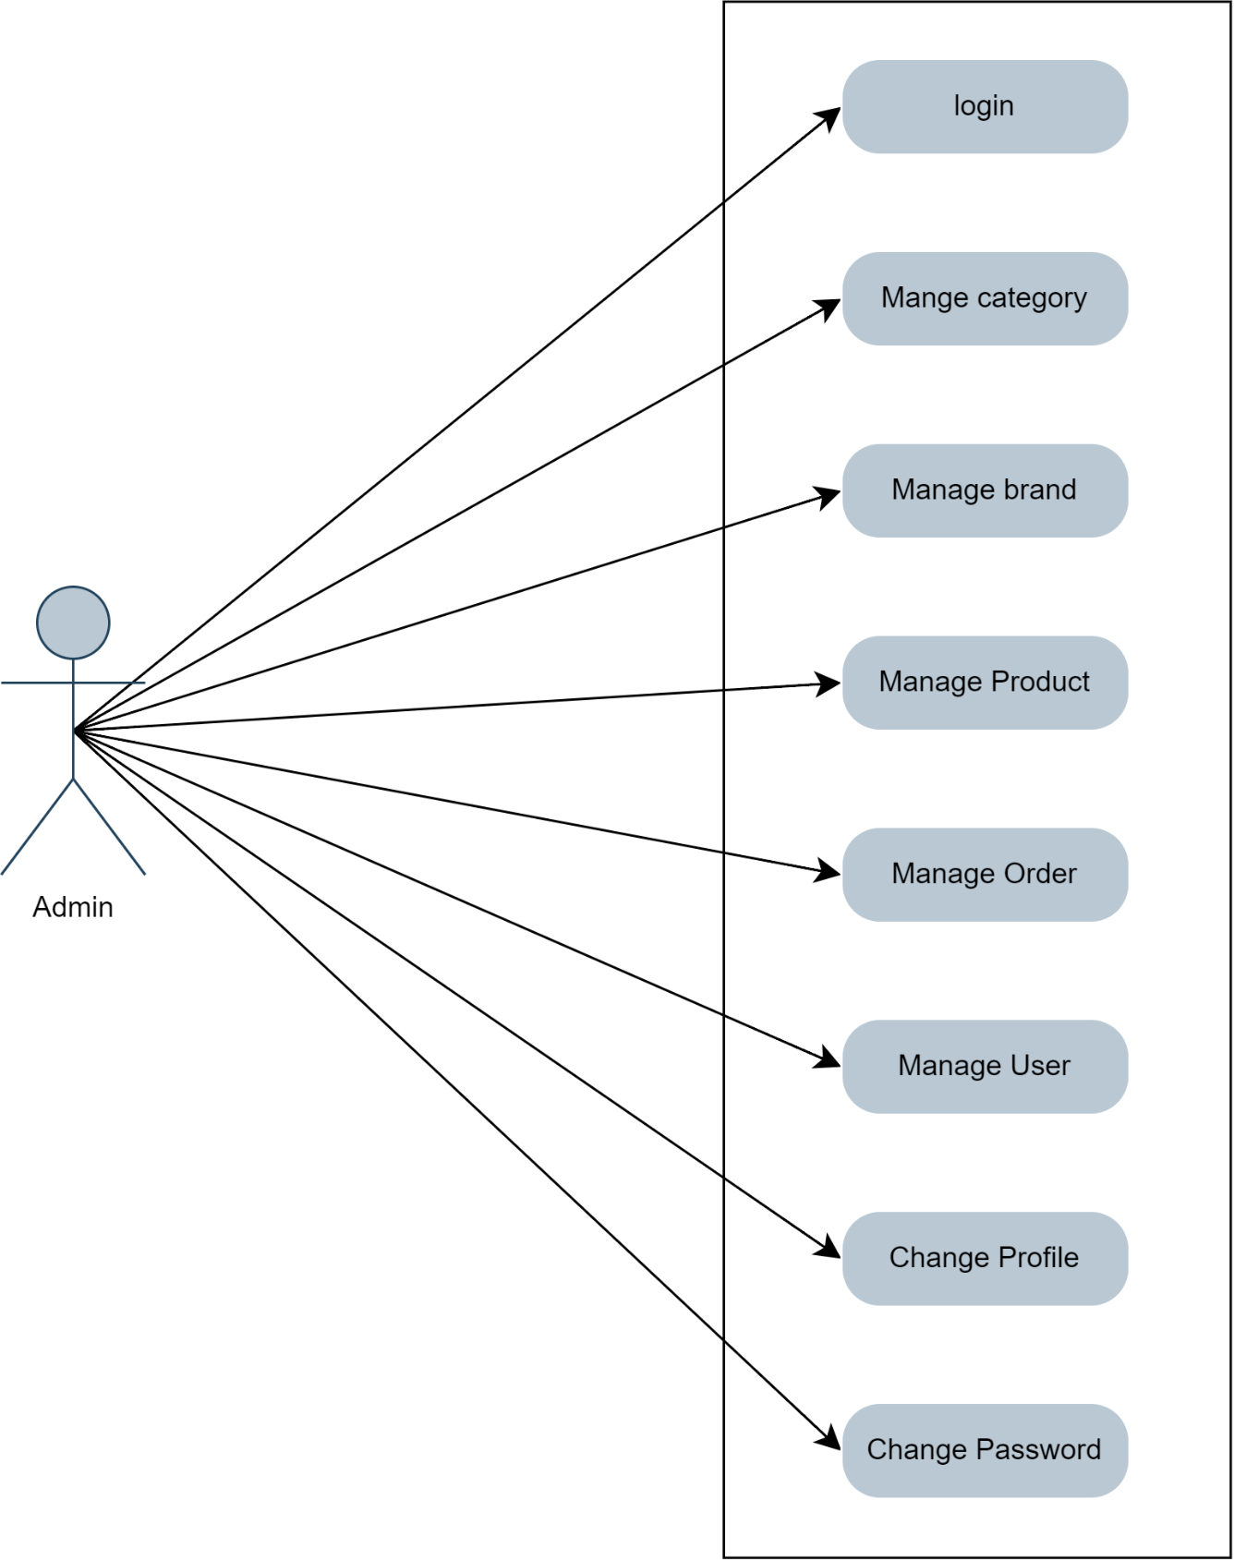

* **user**

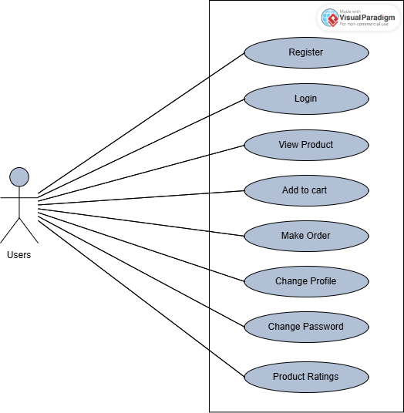

**5.4 Activity Diagram**

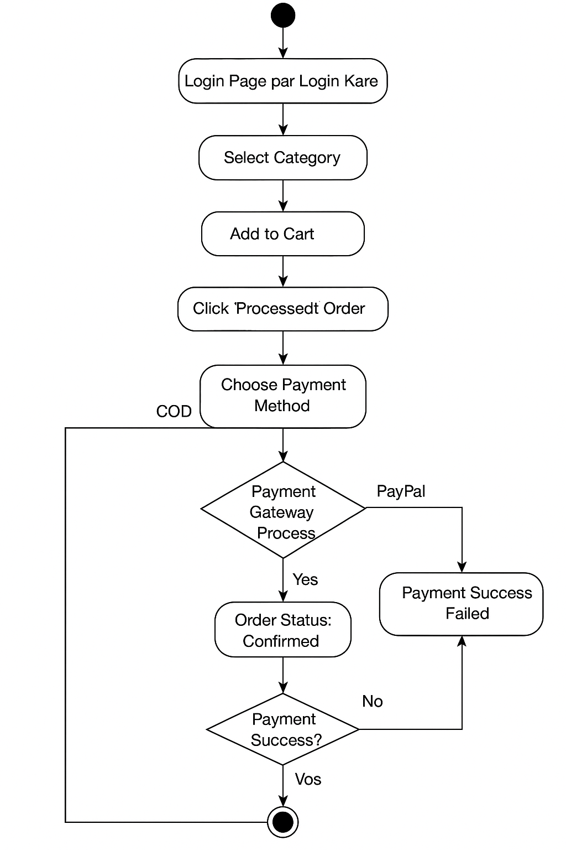

**Yes**

**Login**

**5.5 Class Diagram**

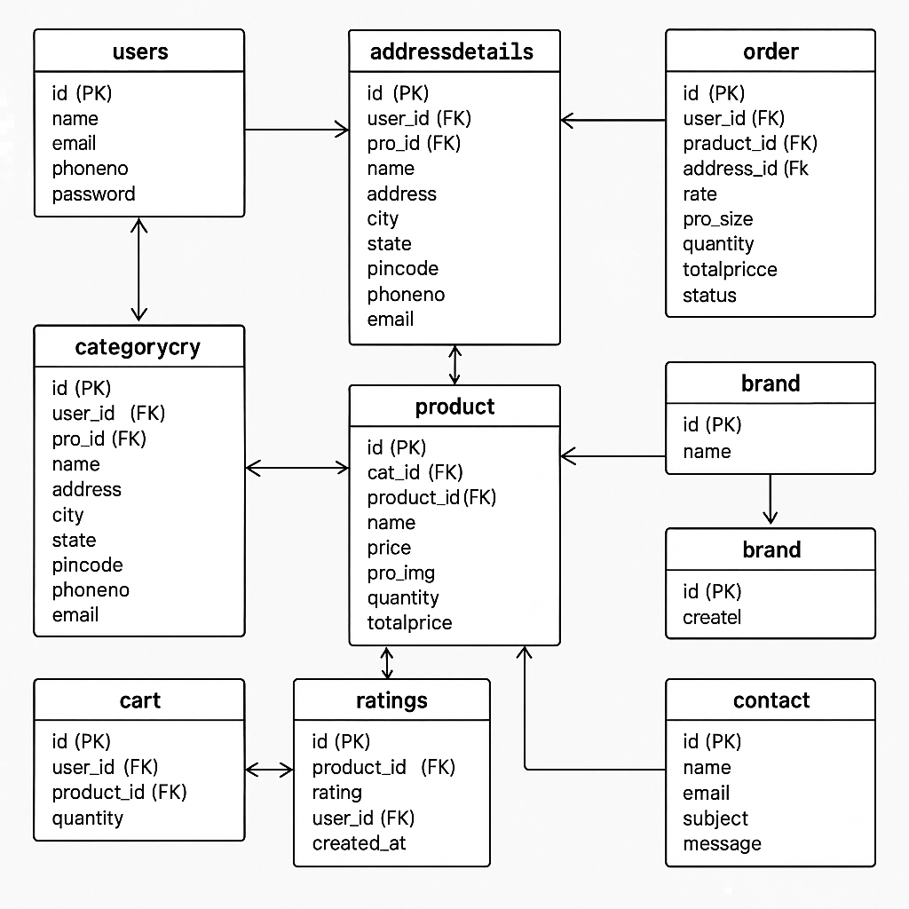

**5.6 Sequence Diagram**

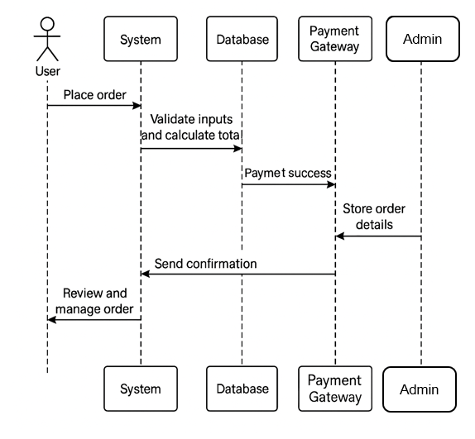

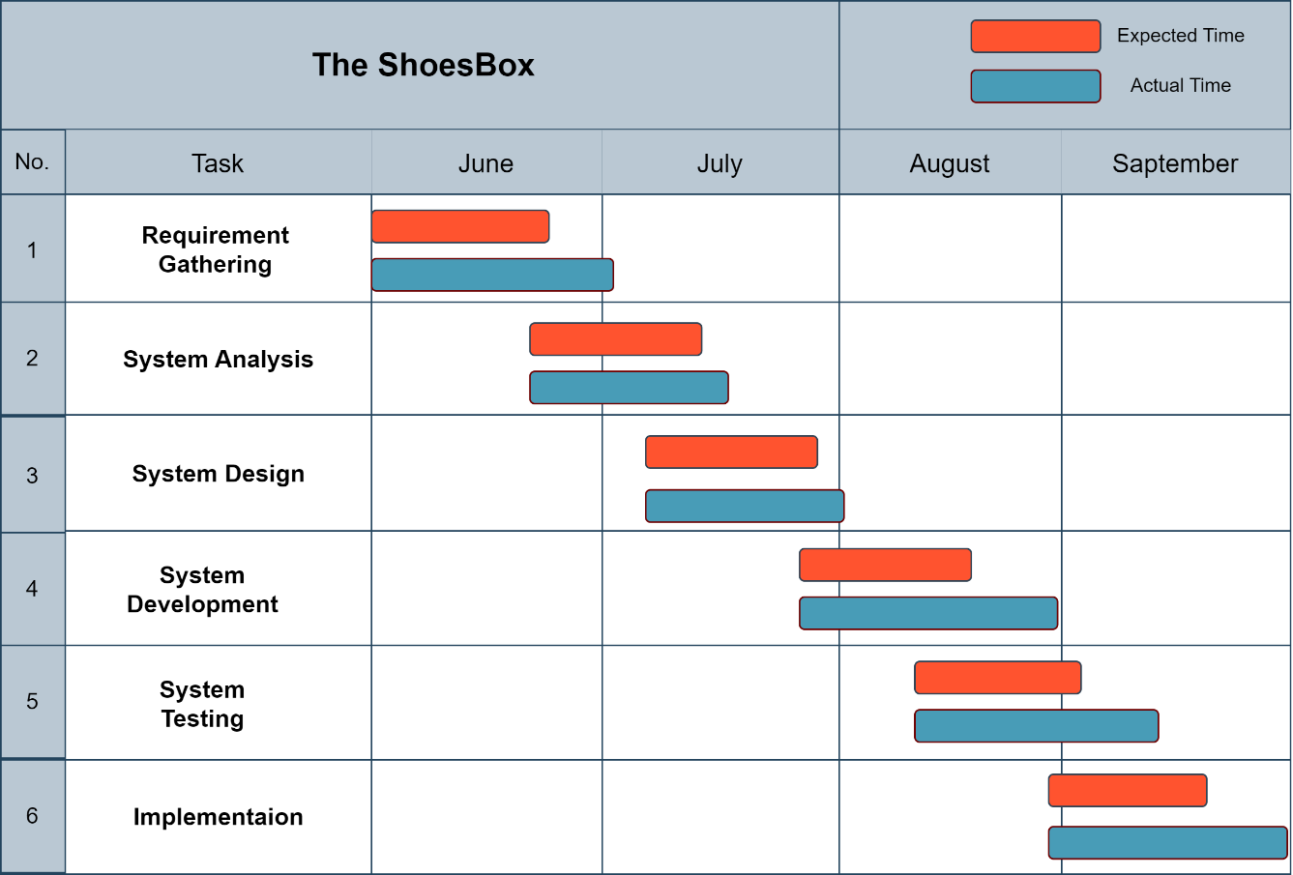**5.7 Gantt Chart**

**CHAPTER 6**

**Screenshots**

* **User Side:**
* Registration Form:

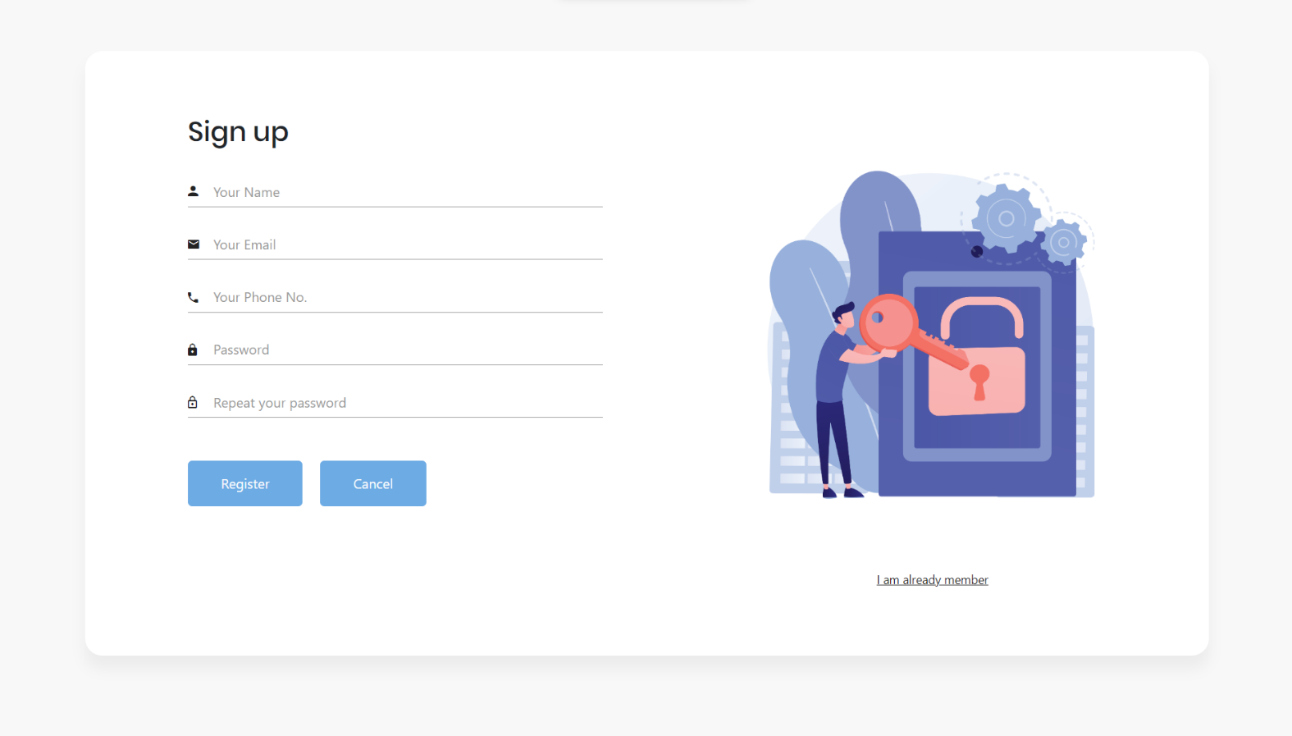

* A registration form is collecting data from the user
* 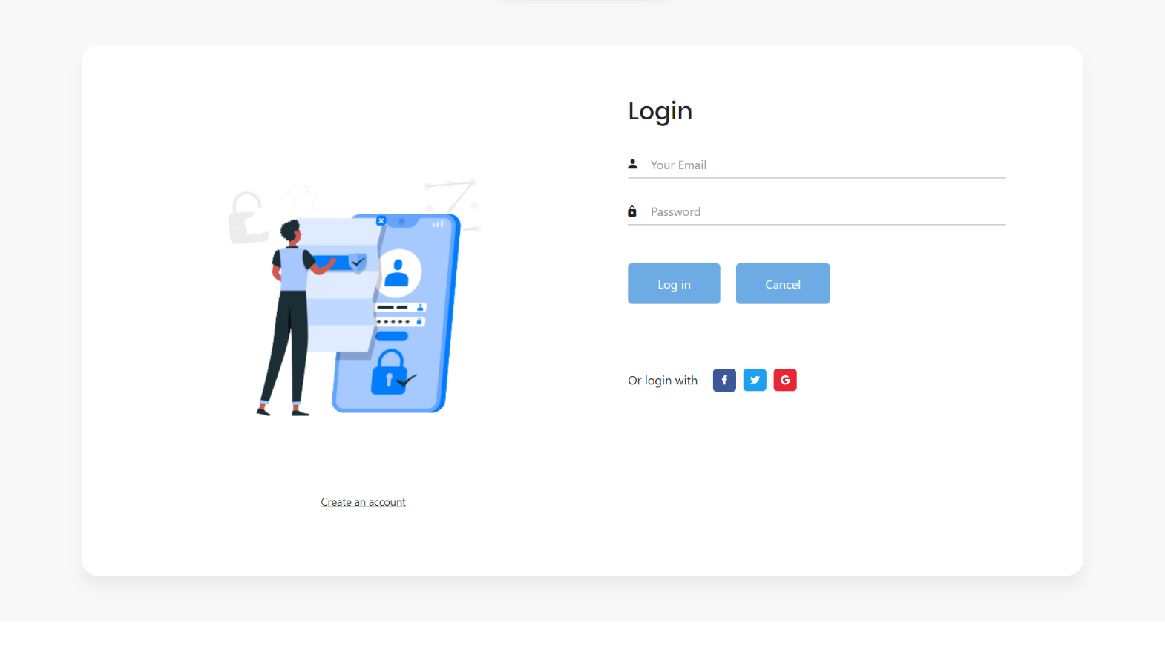**Login Form:**
* **Home Page :**



* User can see category profile or products and contact us
* **Shop Page:**

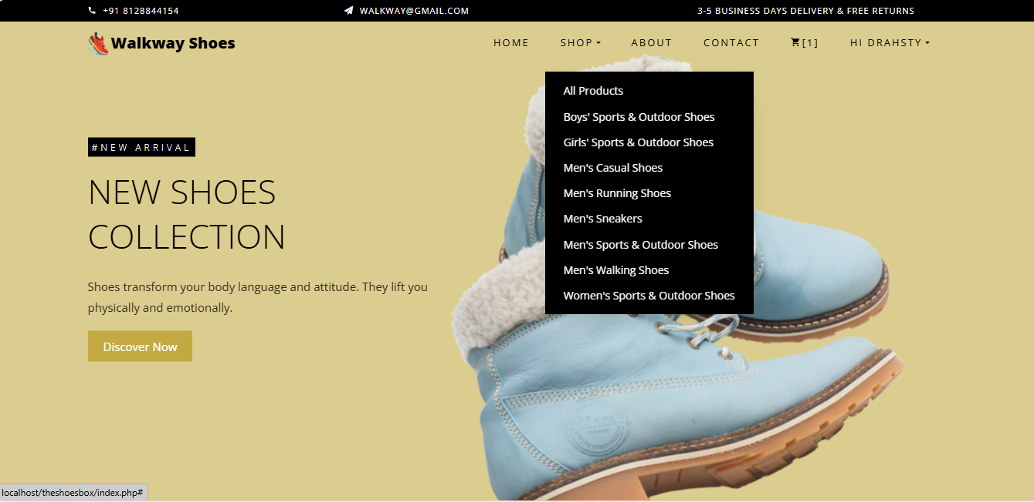

* User can see category and purchase a shoes
* **All Shoes Page:**

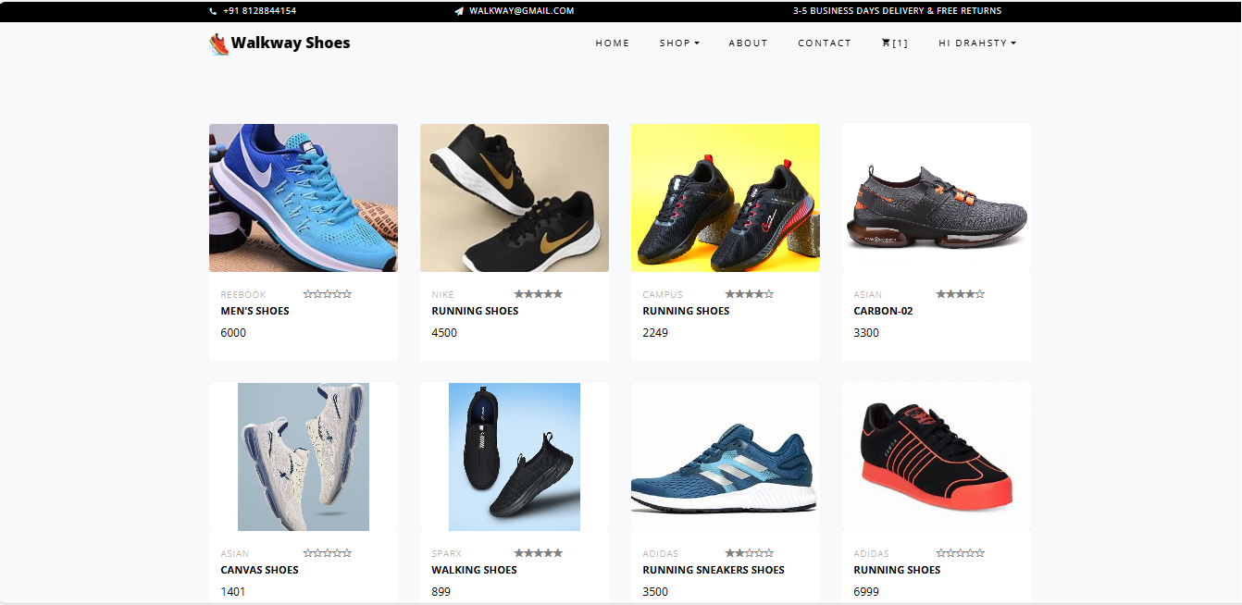

* 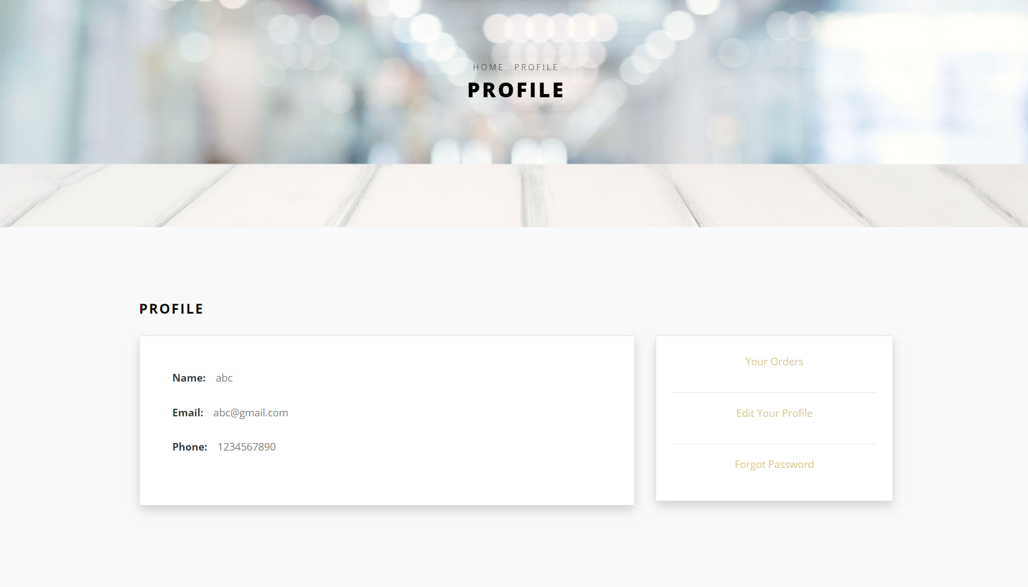**User Profile Page:**
* **Cart Page :**

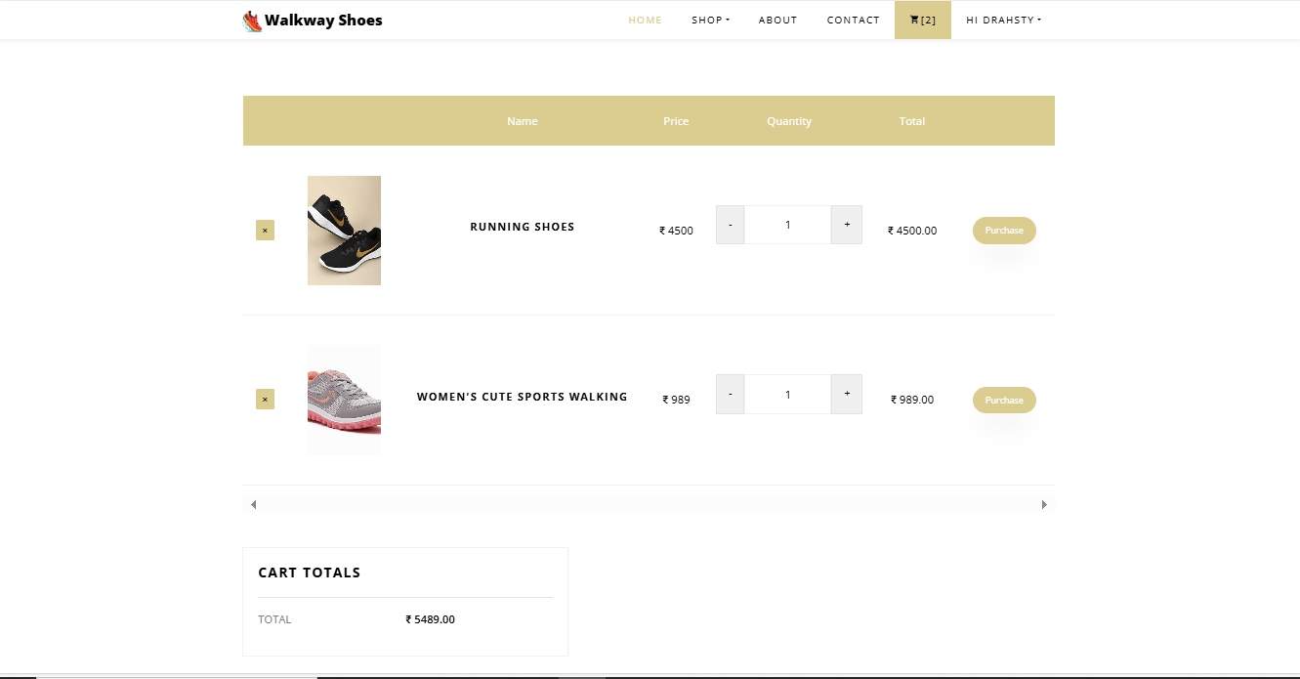

* Add to cart products user can see in his cart
* 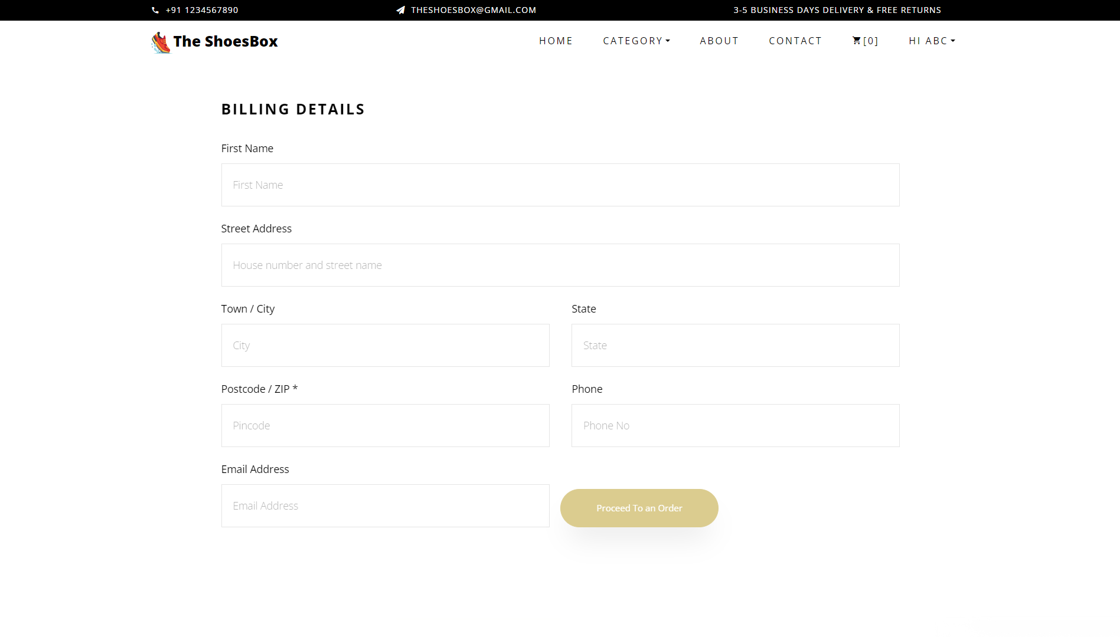**Billing Details:**
* **Checkout Page :**

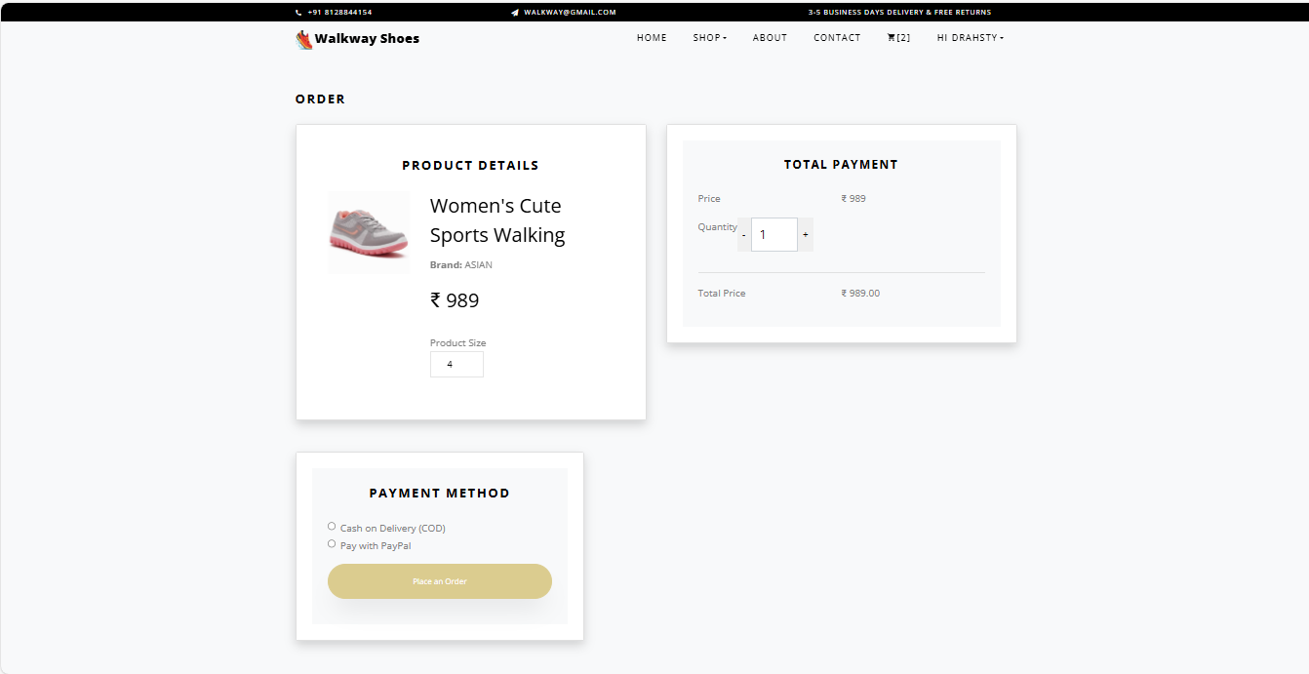

* User can see his product image, product-details, cart-total, and payment method
* Case on Delivery(COD) Payment
* PayPal Payment
* **Order Page:**

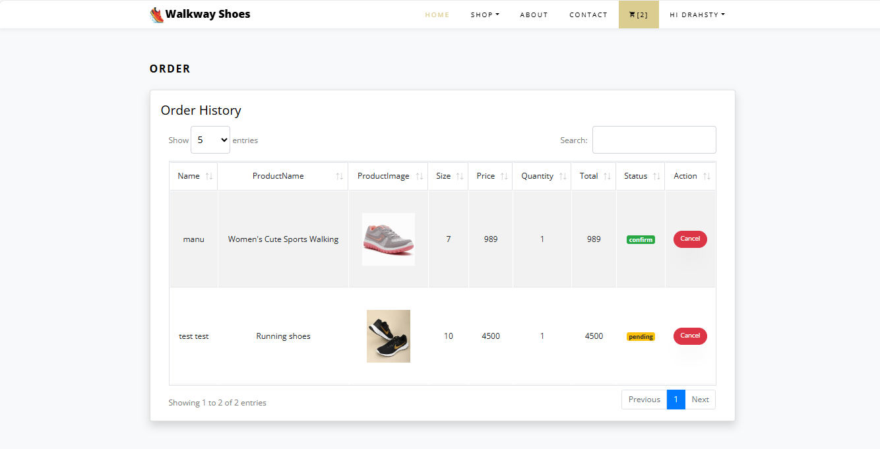

* **Contact Page:**

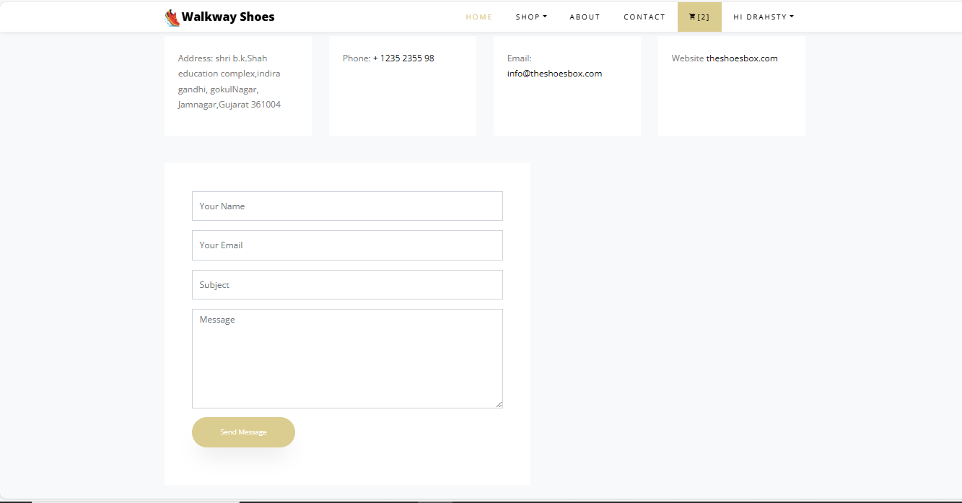

* **Admin Side:**
* 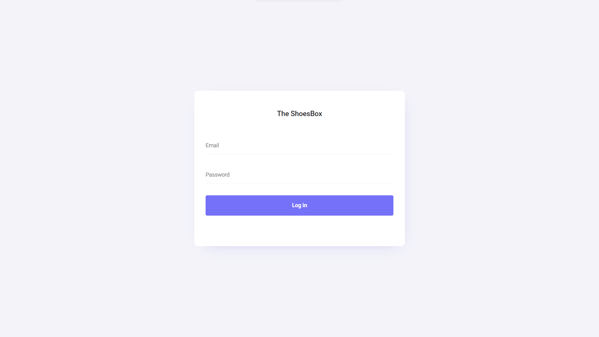 **Login Form:**
* Only Admin can login
* **Product Page :**

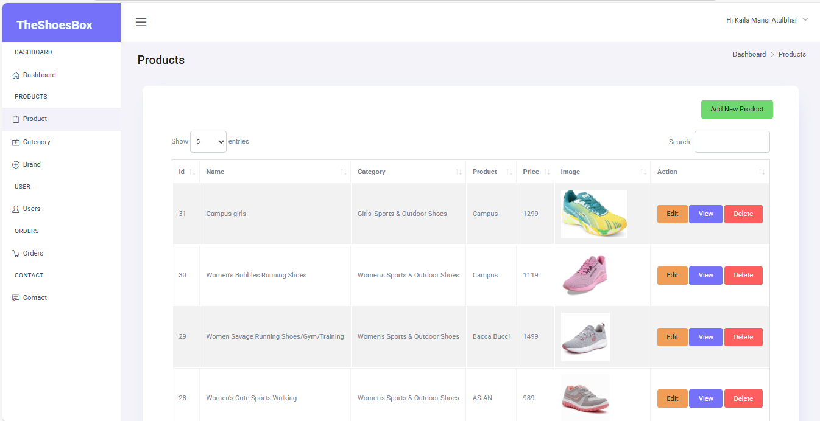

* **Dashboard:**

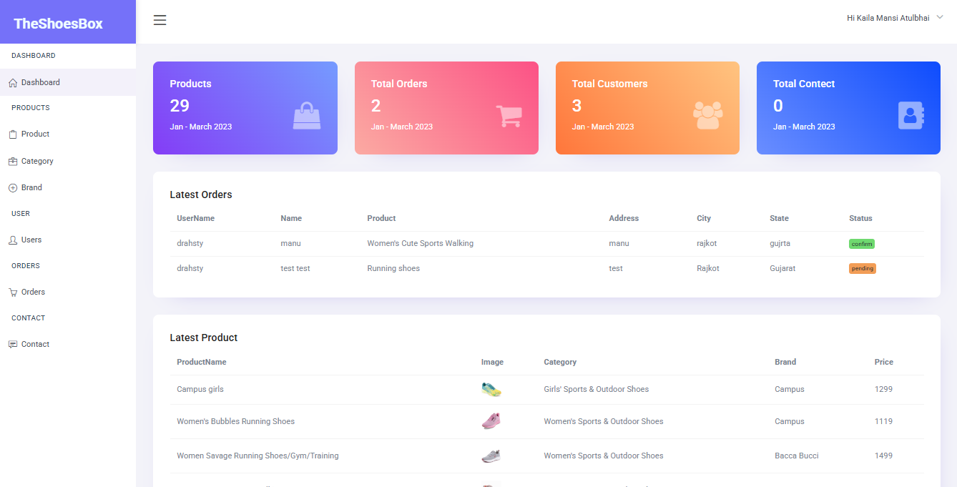

* **Model Page :**

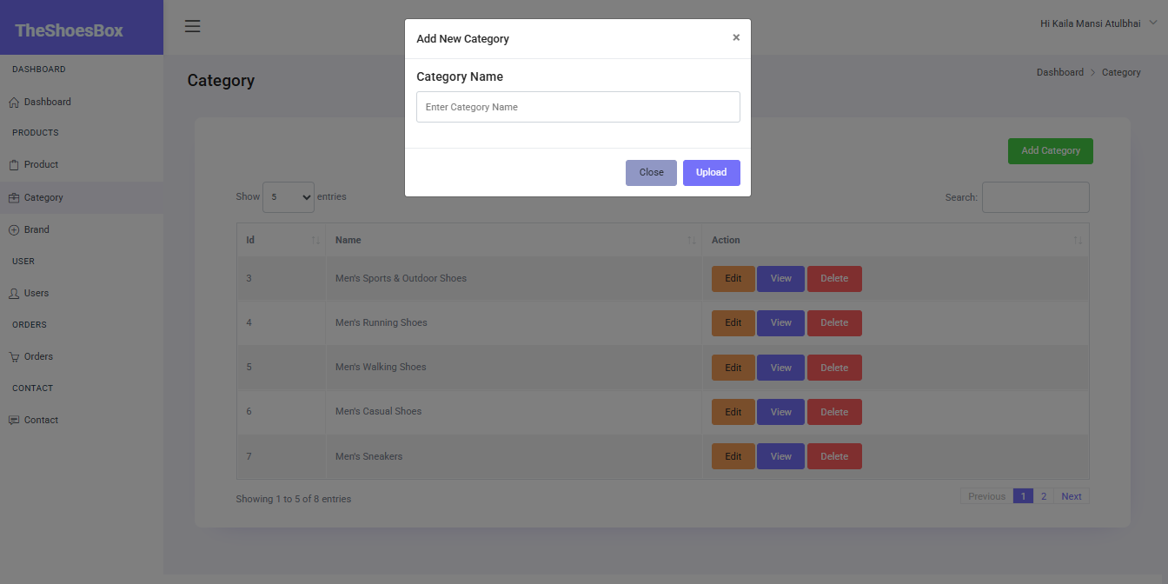

* **Brand Page:**

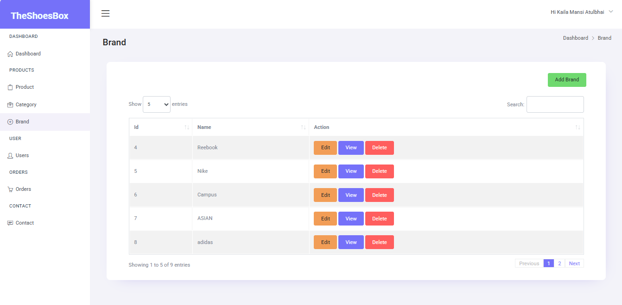

* **Order**

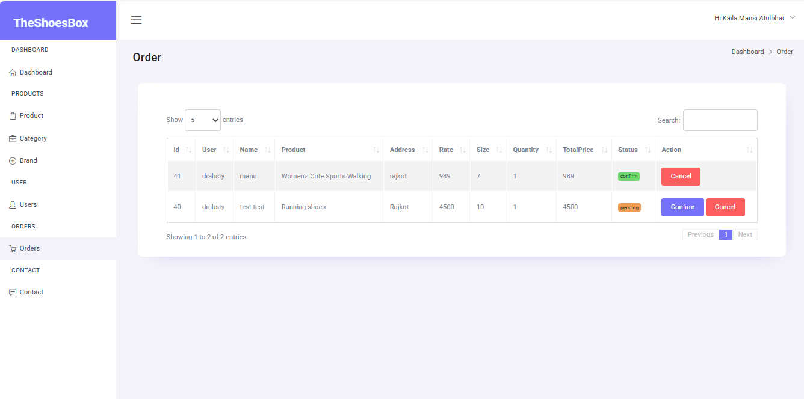

* 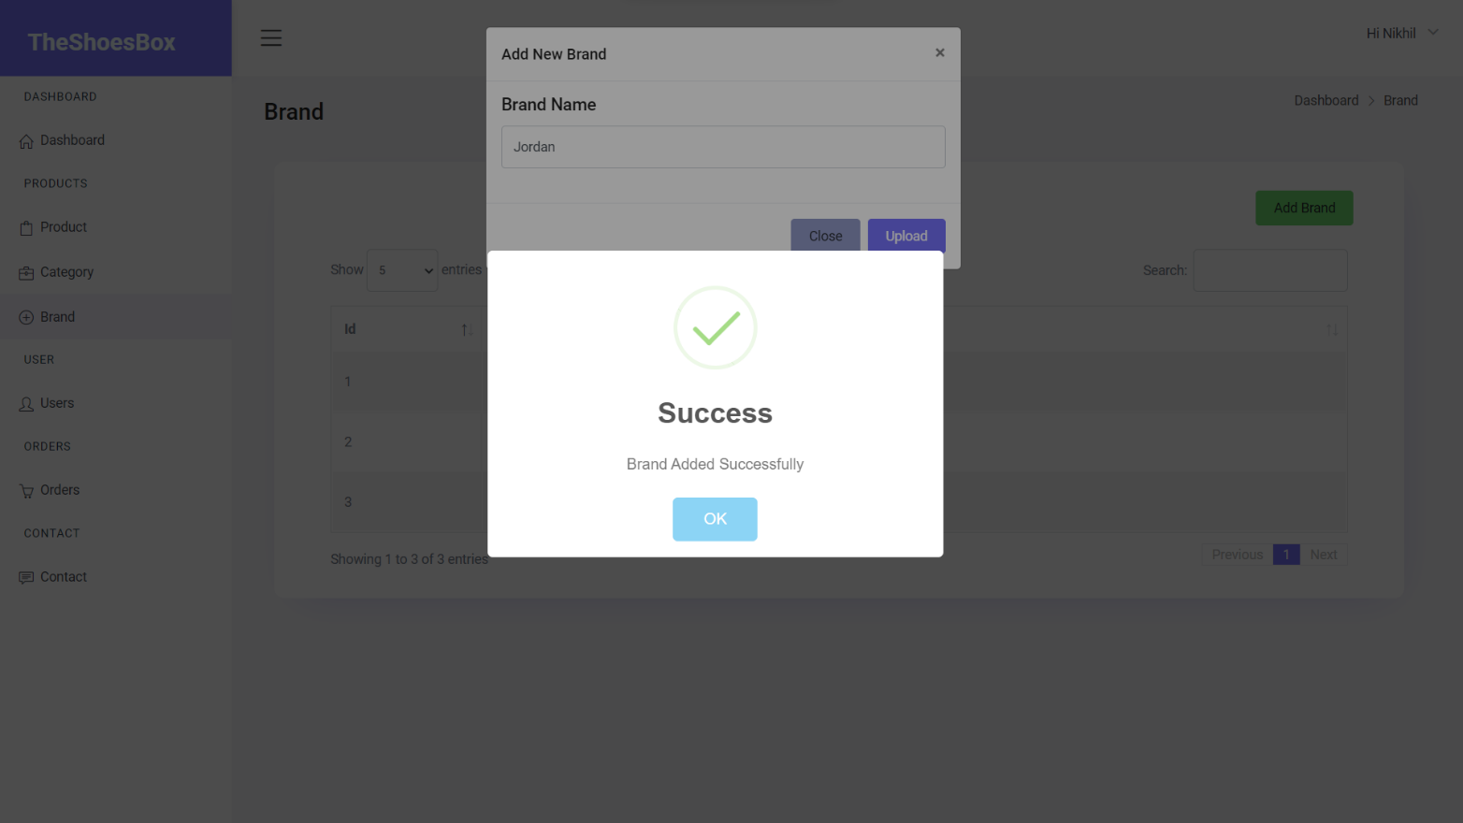**Sweet Alert :**
* **Admin Profile :**

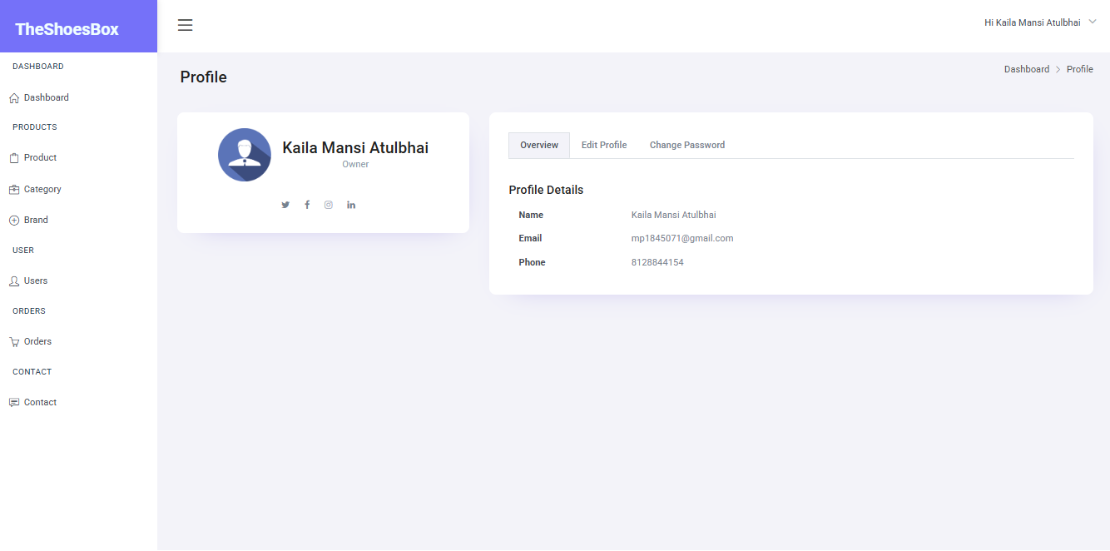

* **Add New Admin or all user’s details:**

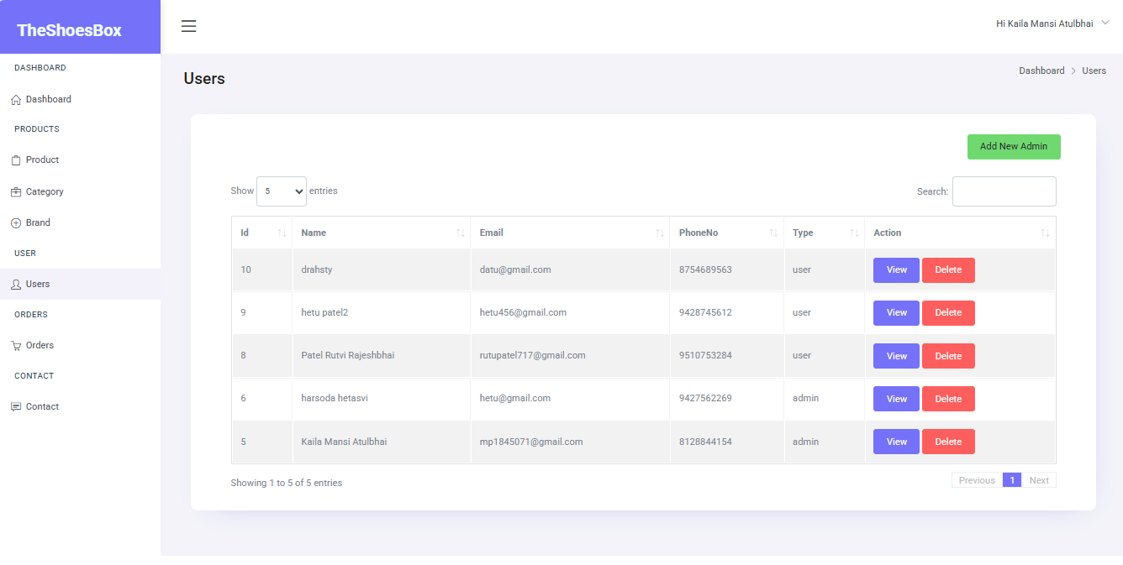

**CHAPTER 7**

**Agile Documentation**

#### **5.1 Project Charter**

* **Vision**:

Create **Theshoesbox**, a customer-focused e-commerce platform offering a seamless, personalized, and secure online shoe shopping experience.

* **Objectives**:

Develop a user-friendly website that simplifies shoe browsing and purchasing  
Enable secure and flexible payment options (COD, PayPal, etc.)  
Ensure smooth performance on mobile and desktop (responsive design)  
Provide easy product navigation with category, brand filters, and search.

* **Scope**:

Includes user registration/login, product catalog, cart, order placement, payment integration, address management, ratings/reviews, and admin controls for managing products, categories, and orders.

* **Stakeholders**:

Product Owner, Development Team, Customers (End Users), Admins, Business Managers

* **Requirements**:
* User authentication
* Product listing and categorization
* Shopping cart functionality
* Checkout with multiple payment options
* Order tracking and status updates
* Rating and review system
* Admin panel for inventory and user management
* **Risks**:
* Security vulnerabilities in payment gateways
* Data loss or corruption
* Slow performance with large product catalog
* Customer drop-offs if UI/UX is poor

### **5.5 Sprint Backlog**

#### **User Authentication System**

* Develop user login functionality.
* Implement user registration with email and phone.
* Encrypt and store passwords securely.
* Conduct basic testing for login/logout processes

#### **Product & Category Management**

* Develop product and category listing pages.
* Implement add/edit/delete functionality for products and categories.
* Upload and display product images.
* Conduct testing for product display and filtering.

#### **Cart & Checkout Flow**

* Implement shopping cart with add/remove/update quantity.
* Design and build checkout process.
* Enable Cash on Delivery (COD) and PayPal payment modes.
* Test complete flow from cart to order placement.

#### **Order Management & Address Handling**

* Develop order history and order details view.
* Allow users to save and manage multiple shipping addresses
* Link orders to user-selected address and payment method
* Conduct testing for accurate order saving and retrieval

#### **Ratings, Reviews & UI Polish**

* Implement product rating (1–5 stars) and review system
* Display average ratings and individual reviews on product page
* Improve mobile responsiveness and UI components
* Conduct final testing and prepare for deployment

**CHAPTER 8**

**Future Enhancements**

* **Personalized Recommendations**  
   Implement AI-based product suggestions based on user browsing and purchase history to boost customer engagement and sales.
* **AR-Based Virtual Try-On**  
  Integrate Augmented Reality (AR) for users to virtually try on shoes using their mobile camera before buying.
* **Advanced Filtering & Search**  
  Enable smart filters (size, color, occasion, material) and voice-based product search to enhance shopping experience.
* **Loyalty Program**

Introduce a rewards/points system to encourage repeat purchases and customer loyalty.

* **Progressive Web App (PWA)**  
  Develop a cross-platform PWA version of the site for fast, app-like experience on mobile devices with offline capabilities.
* **Enhanced Order Tracking**  
   Provide real-time order tracking integrated with logistics APIs for better post-purchase visibility.
* **Multilingual & Multi-Currency Support**  
  Expand customer reach by supporting multiple languages and currencies for international users.
* **Social Commerce Integration**  
  Allow users to share products on social media and purchase via Instagram/Facebook shops for increased reach.
* **Customer Support Chatbots**  
  Deploy a smart Chatbots for 24/7 customer support, handling queries about orders, returns, and products.
* **Eco-Friendly Shopping Options**  
  Highlight sustainable brands and offer carbon-neutral shipping options to attract eco-conscious customers.

**CHAPTER 9**

**TimeLine**

* **Initiation:**
* Define project objectives, scope, and deliverables.
* Establish project team and roles.
* Develop project charter and obtain approval.
* **Planning:**
* Create a detailed project plan, including tasks, milestones, and timelines.
* Identify resources and allocate responsibilities.
* Conduct risk assessment and develop mitigation strategies.
* **Execution:**
* Implement project plans according to the defined schedule.
* Develop and deliver project deliverables.
* Monitor progress and manage resources effectively.
* Conduct regular team meetings and status updates.
* **Testing and Quality Assurance:**
* Conduct thorough testing of project deliverables.
* Identify and resolve any defects or issues.
* Ensure compliance with quality standards and requirements.
* **Deployment:**
* Prepare for project deployment, including installation and configuration.
* Conduct user training and documentation.
* Coordinate deployment activities and ensure smooth transition.
* **Monitoring and Evaluation:**
* Monitor project performance and user feedback.
* Evaluate project outcomes against predetermined success criteria.
* Identify lessons learned and areas for improvement.
* **Closure:**
* Formalize project closure, including documentation and reporting.
* Celebrate project success and recognize team contributions.
* Conduct post-implementation review and handover any remaining tasks.

**CHAPTER 10**

**References and Bibliography**

* All the references listed below were used to develop and design this web application and were also used for documentation. We are thankful to each and every person who helped us and support for this project completion.
* **References**

[**https://chat.openai.com**](https://chat.openai.com)

[**https://stackoverflow.com**](https://stackoverflow.com)

[**https://www.nike.com**](https://www.nike.com)

[**https://www.geeksforgeeks.org**](https://www.geeksforgeeks.org)

[**https://getbootstrap.com**](https://getbootstrap.com)

[**https://www.javatpoint.com**](https://www.javatpoint.com)

[**https://www.w3schools.com**](https://www.w3schools.com)

